BBC News Europe

Challenges in Technology and its Influences on Education and Training

Presenters:  Antoinette Pinder-Darling, Leonard Sheehy and Martha Sosa

Global Issues in Educational Technology Leadership

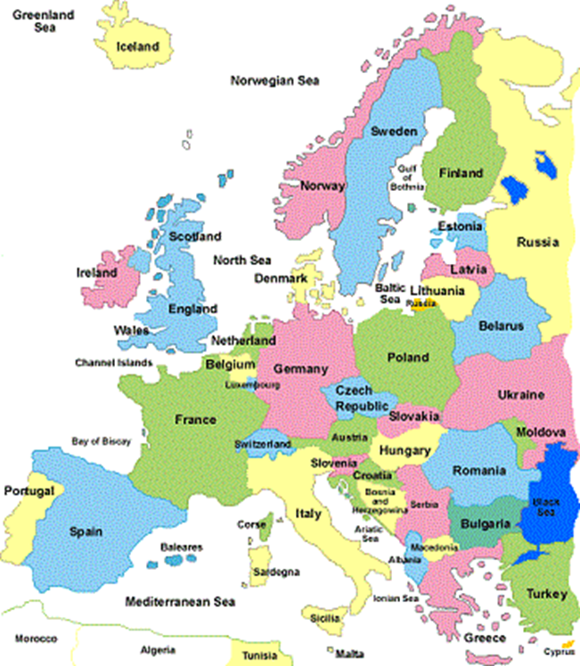

**Introduction**

Europe is currently experiencing a digital divide due to large access gaps across the vast regions throughout the European Union. Technological resources and the effects of Internet and communication technology are some of the factors that are impeding its progress.  One of the biggest challenges may well be the cost factors associated with integrating technology into primary and secondary settings as well as university and corporate classrooms.  This was a concern for close to 70% of university students across European campuses in the late nineties (Marchessou, 1999). Another existing factor is the legal and ethical issues associated with distance learning.

It is essential to engage and motivate learners in order to maximize the use of technology throughout all types of learning environments.   Faculty, teachers and administrators, have to recognize that if learners are going to use technology in the classroom educators must find ways to keep the content meaningful and current.  As governments and corporations expand and adapt to the ever changing needs of the society and the economy, ‘they must think globally and act locally’.

**Figure 1:** European Union

|  |  |  |  |  |  |  |  |
| --- | --- | --- | --- | --- | --- | --- | --- |
| Austria | Belgium | Bulgaria | Croatia | Cyprus | Czech Republic | Denmark | Estonia |
| Finland | France | Germany | Greece | Hungary | Ireland | Italy | Latvia |
| Lithuania | Luxembourg | Malta | Netherlands | Poland | Portugal | Romania | Slovakia |
| Slovenia | Spain | Sweden | United  Kingdom |  |  |  |  |

**Source:** European Union, 2014

K-12 Education

The digital divide can be viewed as one of the main barriers to the growth of Internet and Communication Technology in academic institutions throughout both developed and developing countries.  *(*See Figure 2.) Digital divide can be defined as the gap that exists between those countries that have access to advanced technologies and those that do not (Gasco, 2005, as cited in Afacan et al.).  In a synthesis report, based on data collected for over two decades, the Study of the Impact of Technology in Primary Schools (STEPS) reported that computers in classrooms are a reality in some European schools while other educational settings rely heavily on computer labs.  These findings are based on data gathered from the 30 countries surveyed which include, but are not limited to, Liechtenstein, France, Romania and Denmark.  The survey results represent over 270,000 schools which were involved in this study (STEPS, 2*007).*

**Figure 2:** Developed Countries vs. Developing Countries

|  |  |  |  |  |
| --- | --- | --- | --- | --- |
| **Developed**  **Countries** | Estonia | Italy | Portugal | **Developing**  **Countries** |
| Andorra | Finland | Liechtenstein | San Marino | Lithuania |
| Austria | France | Luxembourg | Slovakia | Moldova |
| Belgium | Germany | Malta | Slovenia | Montenegro |
| Croatia | Greece | Netherlands | Spain | Romania |
| Cyprus | Hungary | Monaco | Sweden | Russian Federation |
| Czech Republic | Iceland | Norway | Switzerland | Serbia |
| Denmark | Ireland | Poland | United Kingdom | Macedonia |
|  |  | Albania | Bosnia & Herzegovina | Turkey |
|  |  | Armenia | Bulgaria | Ukraine |
|  |  | Azerbaijan | Georgia | Latvia |

**Source:** European Union of the Deaf Youth: 2011

**Internet and Communication Technology Structures in Schools**

Numerous state-of-the-art tools are being incorporated throughout the European nations. Interactive whiteboards are one of the primary devices being utilized in many schools across Europe, most notably in the United Kingdom, the Netherlands and Denmark.  According to the STEPS report, in some countries such as Finland, the cost factors associated with interactive whiteboards have resulted in limited access to the devices. Research studies from the United Kingdom indicate that interactive whiteboards engage and motivate students while facilitating cross-school use of Internet and Communication Technology (Underwood, 2009 as cited in Wastiau et al.).

Interactive whiteboards are not the only tools being offered in K-12 academic settings. “There is a clear trend towards laptop purchases in primary schools, probably because of their greater versatility and smaller footprint” (STEPS, p. 14).  Denmark, Estonia and Norway have been known for having the highest levels of platform use. Tablets with a wireless network and a wireless data projector which are enabled to move around between pupils are found to be the most functional devices for classroom use in schools across the EU28, Iceland, Norway and Turkey (Wastiau, 2010 as cited in Wastiau et al.). Furthermore, there are nearly twice as many laptop computers per 100 students in secondary schools in the European Union as compared to the data from 2006. Broadband usage is currently at 95% indicating significant increases compared to 65-75% in 2006 (Wastiau, p. 14). These findings may very well indicate that the EU is continuing to work towards meeting the needs of the 21st century learners.

**Figure 3.** INTERNET COMMUNICATION AND TECHNOLOGY ACCESS

**Source:** The Use of ICT in Education: A Survey of Schools in Europe, 2013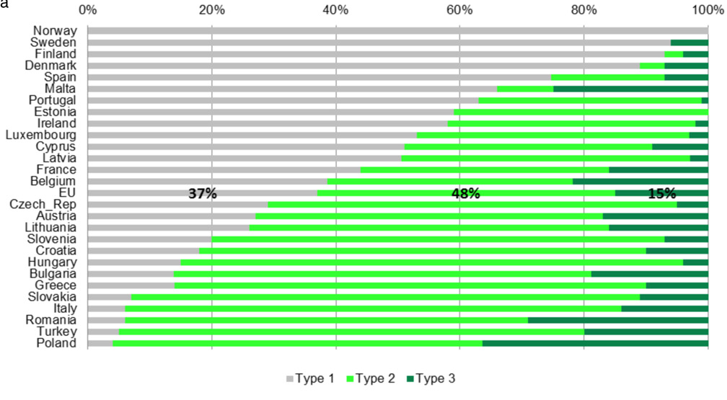

**Type 1**:Highly digitally equipped school, i.e. high equipment level, fast broadband, high connectedness (school website, virtual learning environment, teacher/student email accounts, etc.)

**Type 2**: Partially digitally equipped school (slow or no broadband access)

**Type 3:** Low digitally equipped school (no connectedness)

The Survey of Schools: ICT in Education was commissioned in 2011 by the European Commission Directorate General Communications Networks, Content and Technology to assess and establish a benchmark for the use and attitudes of ICT in educational institutions across the EU28, Iceland, Norway and Turkey. Data from the 31 countries was collected from primary level education, lower secondary level education and upper secondary level education. The results demonstrate that in countries such as Denmark, Finland, Norway and Sweden students have access to highly digitally equipped schools as compared to students in Portugal, Ireland and Luxembourg. Some of the causes that can be attributed to this disparity include lack of financial resources and limited accessibility to technological infrastructures. (See Figure 3.)

**Current Challenges**

One of the top priorities in Europe is to transform its current technological infrastructure in order to compete globally with other countries outside of the European Union.  Even though the day to day penetration of Internet and Communication Technology (ICT) continues to gain momentum there is still a disparity between countries within the EU .  “Europe is catching up with the US and Japan in terms of innovation, but big gaps between countries need tackling” (European Commission, 2014). Even though technology usage has increased globally, the findings have concluded that there is a considerable discrepancy with Internet usage between developed and developing countries.  While in developed countries, 71.6% of inhabitants are Internet users only 21.1%  of the population is utilizing  Internet access in developing countries (ITU, 2010 as cited in Afacan et al.).  These findings are significant since Internet usage not only impacts businesses and health industries, it also greatly impacts the educational systems that make up the European nations.

Turkey is one of the countries that is currently working towards becoming a digital nation by developing the infrastructure for the network of public Internet access points (PIAPs) throughout the country to guarantee equitable ICT access for Turkish citizens.  These (PIAPs) are an essential component in order to equip the classrooms with necessary IT tools needed for both students and instructors.  These tools can also be utilized to develop the IT knowledge and skills needed at the university level in order to compete in a global economy.

Higher Education

**The Future of European Higher Education: A Technological Impact**

The technological focus in training offered to constituents varies between business and higher education—and it does matter that it is not similar (Birnbaum, 2001). Higher education’s distinctive combination of goals, tasks, employees, governance structures, values, technologies, and history makes it distinctly stand out from the corporate world (Altbach, Gumport, & Johnstone, 2001; Thelin, 2004).  Higher education in Europe is different because of its educational mission which adopts sustained efforts of political, administrative and economic unification. A country such as Russia faces leadership challenges as it shifts to adjust to changing cultural values of students and the community. In Germany, there are economical and infrastructural differences as it relates to technology in Western and the former communist Eastern federal states (Nistor, Gogus, & Lerche, 2013). Among other European countries there are differences in terms of technological and educational infrastructure even with a strong focus on technological advancements. In Western European states, television and technological advancements is molding undergraduate minds and values and their way of life which is growing at a startling rate (Nachimuthu, 2012). These undergraduates are changing from the radical center of education and are adopting the mindset that their core values point to taking charge of how they should use technology and not how technology policy-making and planning by governments should influence their lives. An example of this is how undergraduates are using technology in the form of social media to look for truth and value and not rely on what government(s) report.

**European Distance Education**

Online learning is gaining a firm foothold within universities around the world and at a faster pace within Europe. Education systems need to adapt to help remedy this situation. In this regard, higher education is leveraging global shifts to put education within the reach of more and more individuals around the world (Bolman & Gallos, 2011). Figure 1 highlights and distinguishes between the definitions of online learning, purely online and blended learning.

These have become a stark reality through distance education. Thanks in some part to the success of the British Open University, distance education has found acceptance and success. Well-known European distance education programs are found in Belgium, France, Germany, Italy, the Netherlands, Portugal, and the United Kingdom (Albrechtsen, Mariger & Parker, 2001). Ireland has also emerged as a leader in the research and development of new and emerging technologies and their incorporation into education (Marchessou, 1999). Furthermore, the dissolution of the former Soviet bloc and the development of the European Commission has opened new avenues for expanding knowledge and collaboration among the European countries. This development and availability of modern technologies such as computers and the Internet and the technological savvy of many Europeans have provided the entire necessary conditions for a strong distance learning society. In addition, technology may be disruptive in ways not intended as it results in higher incidences of plagiarism, cheating and blatant distraction as European students become more mesmerized with easy and ready access to mobile technologies (Marga, 2004). The higher education environment is influencing the type of tools or technologies used and needed to complete some tasks, as it will also influence cultures as they continue to develop such technologies. 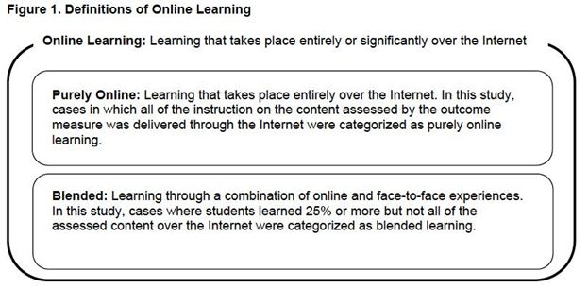

**Technology on European College/University campuses and Societies**

Technology is having a strong impact on campuses. Faculty members just like students have to adjust to the use of new digital technologies in the university environment as they continue to evolve. As technology is constantly changing, teaching faculty need regular support to keep-up-to-date. 

Therefore, greater effort is needed in the area of professional development training for faculty so that they can continue to keep university students engaged. Denmark shares an active tradition of adult education and lifelong training which is naturally technology oriented (Marchessou, 1999). The Norwegian scene is quite similar, with the strength of the public sector, they have an IT plan established for the same length of time and with the same objectives as in Denmark and offer interesting initiatives in distance education. In Sweden, the long tradition of public policies in educational technology remains, but recent purse-tightening as a result of the recession has led to a shift. Moving further south, Italy and Spain present similarities and differences: in both cases, the home market for educational multimedia has been appropriately developed.

Distance Education has become a geographical necessity and across the continent--it remains a prime interest to alleviate imbalances when it comes to the actual integration of educational technologies in the college/university environment. Things are quite different in the United Kingdom with its strong, well established tradition of online and distance learning and public initiatives. To this end, several pan-European societies have been created over the decades. While some of these academic institutions originally focused on the traditional book-and-paper media, the development and use of modern technologies has become a major part of these societies’ networking (Albrechtsen, Mariger & Parker, 2001). With respect to technology and its educational use, Germany displays high technology diffusion, while Turkey and Romania make efforts to intensify the use of educational technology. While distance education is a necessity for Turkey; it comprises a relatively small part of higher education in Germany; and is still operating as an experiment in Romania (Nistor, Gogus, & Lerche, 2013). It is well-known that the technology gap is widening between rich and poor countries. If distance education is to spread around campuses and the globe, beyond the economic wealth of Europe, then consideration must be given to the particular needs of European countries with lesser means. This may mean that the very technology that is part of widening the gap can also be used to close it. Over the next decade, advanced technologies will put education within the reach of many individuals and therefore teaching methodology has to be restructured as well to support the adoption of technology on college and university campuses.

**Implications for STEM Educators**

It seems to be unanimously accepted that professions in the domains of STEM fields promptly adopt top technologies, including educational applications, in a fashionable way (Wang, 2010). The goal for university educators is to provide meaningful opportunities for their undergraduate students to engage in cultural discussions and realize that culture will always surround their lives: personal, educational, technological and professional. Computers and other technological devices are an innovative way for undergraduate students to be able to express their experiences, beliefs, and so much more through their experiences with hardware or software within the university classroom environment or throughout European university campuses. 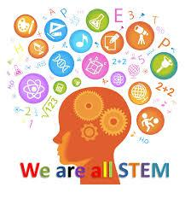

There are at least three innovations that come to mind in the higher education environments which achieves so much momentum through wide implementation in the university culture at large which cannot be ignored by educators in Europe – and these are social networking, mobile and handheld computing devices and gaming. These are almost guaranteed to have permanent roles in higher education. Social networking and Web 2.0 applications have been spectacularly successful in Europe on a large scale (Maddux & Johnson, 2011). However, true integration of technology will require solving the problem of differential access to technology-related, effective learning experiences. Presumably, the fast technology diffusion within universities is because STEM professionals possess more related knowledge and skills which can affect change in higher education throughout European classrooms, communities as well as corporate world.

Whether it is a business, a public entity, or a non-profit association, it is now impossible for an organization to function without using digital technology in its external and internal communications. The digital organization needs to coordinate communications and instruction with its key group: its staff and the best avenue for this to happen will have to be through training efforts.

CORPORATE TRAINING

The manner in which workers learn is becoming more flexible and responsive. The current workforce has more information available to them at faster speeds and they are more likely to create and share information than in the past. Employees learn best by doing their jobs. Studies have shown that skills in the workplace are gained from trying new solutions, making mistakes, and asking questions of colleagues and friends (Simmons, 2014). Employees now gain knowledge by participating in personal and professional networks and communities. Common conservations and meetings are more likely to supply knowledge than traditional training sessions. Google, external blogs and news feeds are resources for employees today. Managers need to recognize this and use technology as a training tool allowing their employees to learn from networking, not top down structured instruction (Hart, 2014).

Developing a culture of collaboration is the foundation of propagating knowledge today. The keystone to creating this philosophy is trust. European corporations are slower to grant trust, however once it is bestowed the relationship lasts longer than in the United States (Fitzpatrick, 2014). This collaborative culture is less of a geographical issue than a generational one. Younger workers are more likely to share and build social networks than older ones because they have been exposed to this environment most of their lives. All members of the workforce however can develop confidence in this system if management provides a motivating atmosphere by creating a collaborative infrastructure (Cross, 2013).

This collaborative infrastructure is based on the theory that learning depends on the different perspectives among co-participants (Lave & Wenger, 1991). Learning, understanding and meaning are not self-contained structures, but depend on a team of individual contributions. The final outcome should not be focused on the knowledge level of one person but the aggregate value of participation of the entire group (Lave & Wenger, 1991). Collaborative infrastructure is the network that links workers with what they need to work and learn: co-workers, information, customers, news, models, plans, directives, gossip and more (Cross, 2013). Corporate training officers need to develop a culture that takes advantage of all these areas. Expertise locators, content management systems, blogs, feeds, search tags, and indexes are some of the tools in which workers require training in today’s world. These provide employees the ability to share solutions to problems and come up with new ideas.

Leaders need to recognize that learning now takes place every day at the workplace. Organizations need to create cultures that foster this environment by removing obstacles, developing communities, encouraging networking and stimulating conservation. Learning must take place at work because the pace of progress is faster than ever before and organizations that fail to recognize this will die (Simmons, 2014).

Jay Cross CEO and Chief Learning Officer of Internet Time Alliance, suggests implementation of the following steps to create a collaborative culture:

* Focus on all workers not just those that are new or need the most help
* Don’t punish failed experiments, if you never fail, you are not innovating
* Create a directory that enables people to locate information from the correct individual
* Encourage people to present their work to others
* Root out information hoarding, make sharing the norm
* Reduce cycle time with instant messaging, Twitter and podcasts, the world is not going any slower
* When feasible, substitute self-service and peer learning for workshops.

(Cross, 2013)

This new environment will lead to a digital divide in two ways. First unemployed individuals will not have access to the current knowledge base. They will not have the same opportunities as employed people. Also, smaller companies with fewer employees will have less of a community of information from which to draw information. 

**Recommendations**

* Develop the infrastructure for the network of public Internet access points (PIAPs) throughout Europe.
* Create a plan to narrow the gaps in performance between the countries within the European Union.
* Create common policies for ICT development and teacher professional training across the European Union.
* Create programs to address inter-European synergies so that student mobility and community learning can be achieved.
* Invest funding and offer teacher training so that language barriers can be addressed through linguistic instruction either through international conferences and workshops or through video and multimedia avenues.

**Conclusion**

The relationship between technology and learning is among the most important topics in higher education in Europe, and increasing in importance. While there are many areas of concern to observers of this topic, Gerald Van Dusen (2000) has alluded to three primary areas that should be addressed: issues of access and equity, issues of cost and affordability, and issues of quality and effectiveness. Not surprisingly, these represent the same three areas of critical challenge to the success of colleges and universities in other regions, as the struggle to make higher education more accessible, more affordable, and more effective is examined in European academic institutions.

This report provides a brief yet thorough analysis of the major challenges in daily efforts to enhance teaching and learning with technology in European schools, corporate institutions and higher education. It also highlights those areas that can be further improved or developed especially in cases where technology carries a significant amount of risk and when its implementation does not meet specified goals or outcomes. The basic issues that can cripple technology usage in K-12 settings are also the areas that are needed to support technological functions, as well, in core academic units in higher education. This is not to say that technology cannot serve as a fertile source of management ideas and innovations but not at the expense of the cultural values of the human capital and the need to effect progress within academic institutions and the corporate world.

BIBLIOGRAPHY

Afacan, G., Er, E., & Aifoglu, A., (2013). Public internet access points (PIAPS) and their social

         impact; A case study from Turkey. *Behaviour & Information Technology.* Vol. 32, No. 1,

         14-23, <http://dx.doi.org/10.10.1080/0144929X.2011.582149>

Altbach, P. G., Gumport, P. J., & Johnstone, D. B. (2001). *In defense of American higher*

*education.* Baltimore, MD: John Hopkins University Press.

Albrechtsen, K., Mariger, H., & Parker, C. (2001). Distance education and the impact of technology in Europe and Japan. *Educational Technology Research and Development, 49*(3), 106-115.

Balanskat, A., (2007). STEPS study of the impact of technology in primary schools (Synthesis

         Report). Retrieved from

<http://eacea.ec.europa.eu/llp/studies/documents/study_impact_technology_primary_school/02_sy>

         nthesis_report_steps_en.pdf

Birnbaum, R. (2001). *Management fads in higher education: Where they come from, what they*

*do, why they fail.* San Francisco, CA: Jossey-Bass.

Bolman, L. G., & Gallos, J. V. (2011). *Reframing academic leadership*. San Francisco, CA:

           Jossey-Bass.

Cross, J. (2013, Sept 30). *Why Corporate Training is broken and how to fix it*. Retrieved on

         September 25, 2014 from Internet Time Alliance:

[http://l1.osdimg.com/online/dam/pdf/en/resources/wp/Jay-Cross-GoToTraining-Why-Corpor](http://l1.osdimg.com/online/dam/pdf/en/resources/wp/Jay-Cross-GoToTraining-Why-Corporate-)

[ate-](http://l1.osdimg.com/online/dam/pdf/en/resources/wp/Jay-Cross-GoToTraining-Why-Corporate-)Training-is-Broken-and-How-to-Fix-It-white-paper.pdf

Dusen, G. V. (2000). *Digital dilemma: Issues of access, cost, and quality in media-enhanced and*

*distance education.* San Francisco, CA: Jossey-Bass.

European Commission: 2014. (Online) <http://ec.europa.eu/news/business/140305_en.htm>

(Accessed November 4, 2014).

European Union: 2014. (Online) <http://europa.eu/about-eu/countries/index_en.htm>

(Accessed November 6, 2014).

Eurropean Union of the Deaf Youth: 2011. (Online)

<http://www.eudy.info/youthcamp2012/Developed%20and%20developing%20European%20countries.pdf> (Accessed Nov. 6, 2014).

[Fitzpatrick](http://uk.linkedin.com/in/patrickfitz), P. Co-Founder and director demographic info Sheffield, United Kingdom

         E-Learning (personal communication, September 17, 2014)

Hart, J. (2012). *Informal survey of importance of sources of learning*. Retrieved on September

         25, 2014 from Centre for learning & performance technologies: [www.c4lpt.co.uk](http://www.c4lpt.co.uk)

Kwok-Wing, L. (2011). Digital technology and the culture of teaching and learning in higher

         education. *Australasian Journal of Educational Technology, 27*(8), 1263-1275.

Lave, J., & Wenger, E. (1991). *Situated learning: Legitimate peripheral participation.* Boston,

         MA: Cambridge University Press.

Maddux, C., & Johnson, D. (2011). Technology in Education and the Concept of Cultural

         Momentum. *Computers in the Schools, 28*(1), 1-4. doi:10.1080/07380569.2011.553150

         Marga, A. (2004). University reform in Europe: Some ethical considerations. *Higher*

*Education in Europe, 29*(4), 476-480.

Marchessou, F. (1999). From instructional technology (IT) to open and distance learning (ODL): A brief overview of educational technology in Western Europe. *Educational Technology Research and Development, 47*(1), 113-123.

Nachimuthu, K. (2012). Technology is an embedded agent of cultural impact. *Journal of Educational Technology, 9*(1), 23-30.

Nistor, N., Göğüş, A., & Lerche, T. (2013). Educational technology acceptance across national

         and professional cultures: a European study. *Educational Technology Research &*

*Development, 61*(4), 733-749. Doi:10.1007/s11423-013-9292-7

Simmons, W. Corporate training Cablevision (personal communication, September 16, 2014)

Sleight, D. (1993). *A Developmental History of Training in the United States and Europe.* Ann Arbor, MI: Michigan State University Press.

Thelin, J. R. (2004). *A history of American higher education*. Baltimore, MD: John Hopkins

         University Press.

Twomey, C. (2014, September 10) New Jersey City University, Go to meeting.

Wang, P. (2010). Chasing the hottest IT: Effects of information technology fashion on

         organisations. *MIS Quarterly, 34*(1), 63-85.

Wastiau, P., Blamire, R., Kearney, C., Quittre, V., Van de Gaer, E., & Monseur, C. (2013). The

use of ICT in education: A survey of schools in Europe. *European Journal of Education,*

*Part I, 11-27.*